- Purpose

To outline steps to calibrate the PH probe located in the waste line (Asset Tag #10035) at the rear of the plant near the water recovery system

- Scope

This procedure applies to the sewer pH probe at the Manufacturing facility. The probe shall be changed out whenever the life of the probe wears out.

- Responsibility

Maintenance

- Safety Considerations

Safety glasses and appropriate safety apparel is to be worn at all times. This includes wearing the appropriate protection for working at heights above six feet.

Safety is a condition of employment. Employees are not authorized to work in an unsafe manner and are prohibited from harming the environment of the facility or community.

- Materials/Equipment

- 3 – 250 ml Plastic Beakers
- Calibration Buffers pH 4 and 7
- Deionized Water
- Wipes or Tissue

- Procedure

This calibration procedure should be conducted during the morning and checked in the afternoon if a new probe was installed.

- Set-up and procedure
- Pour buffers and water in the containers

- After removing the reservoir cover, remove the probe from the holder, clean with De-ionized water and wipe dry with tissue.

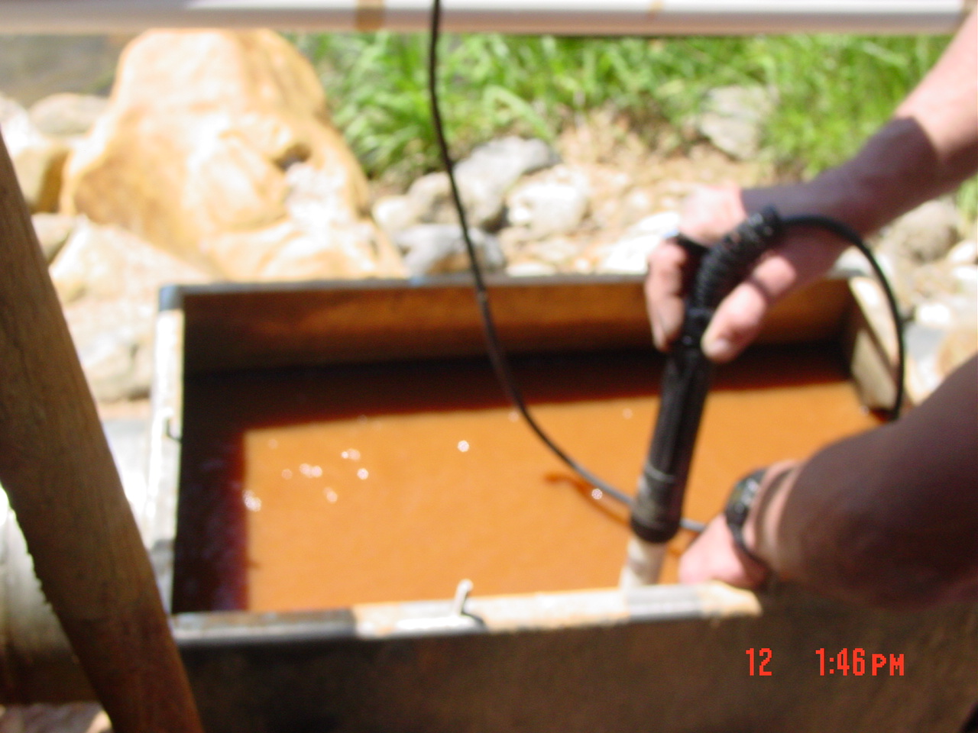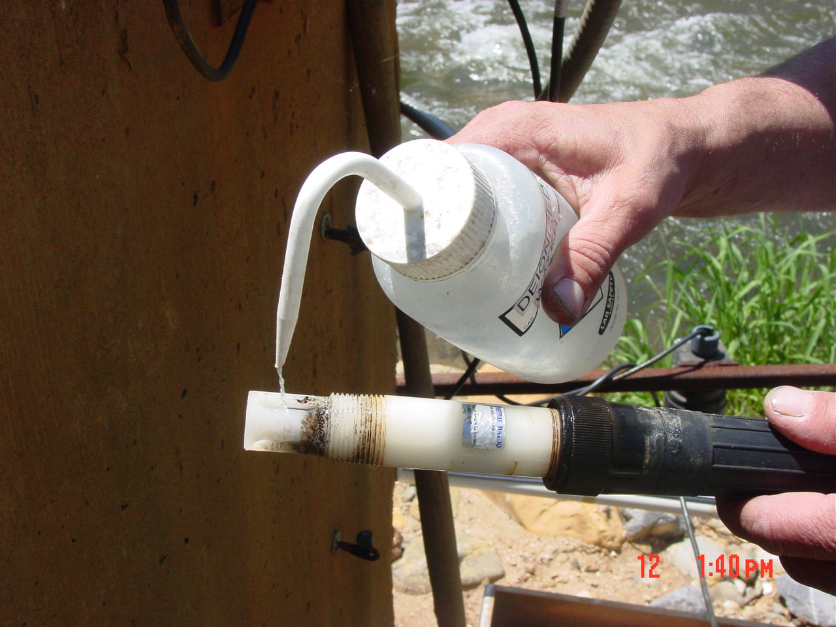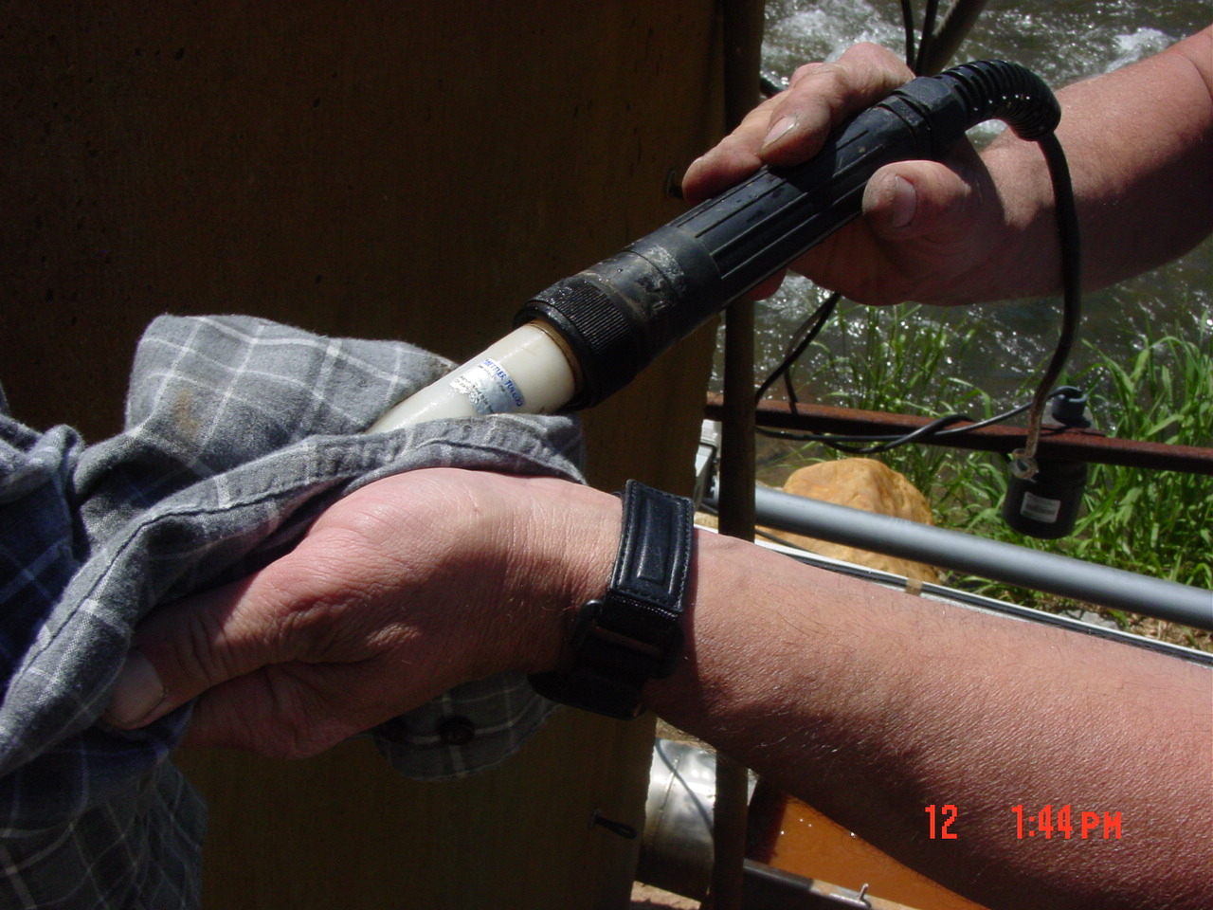

- Place in 4 buffer and observe the reading.

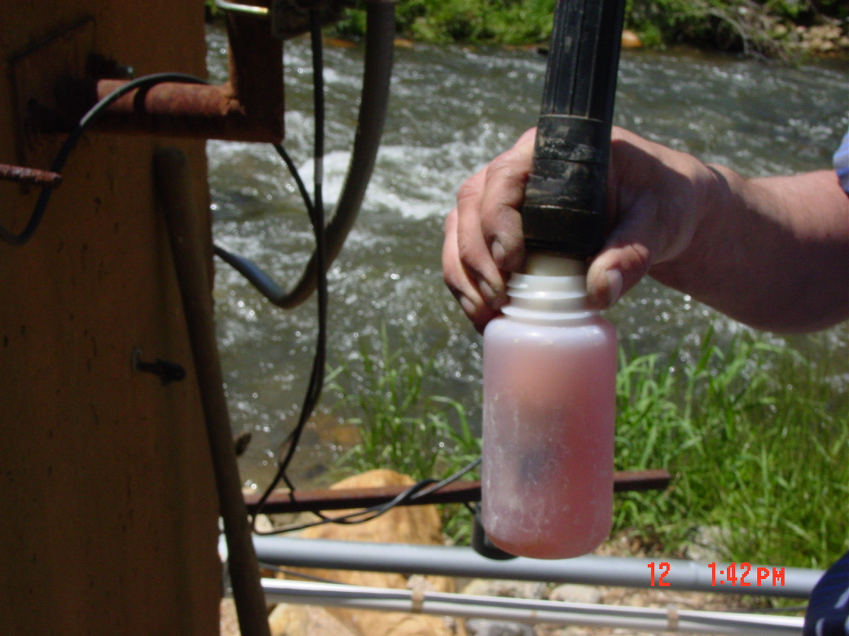

- Press the Calibrate button on the controller box.

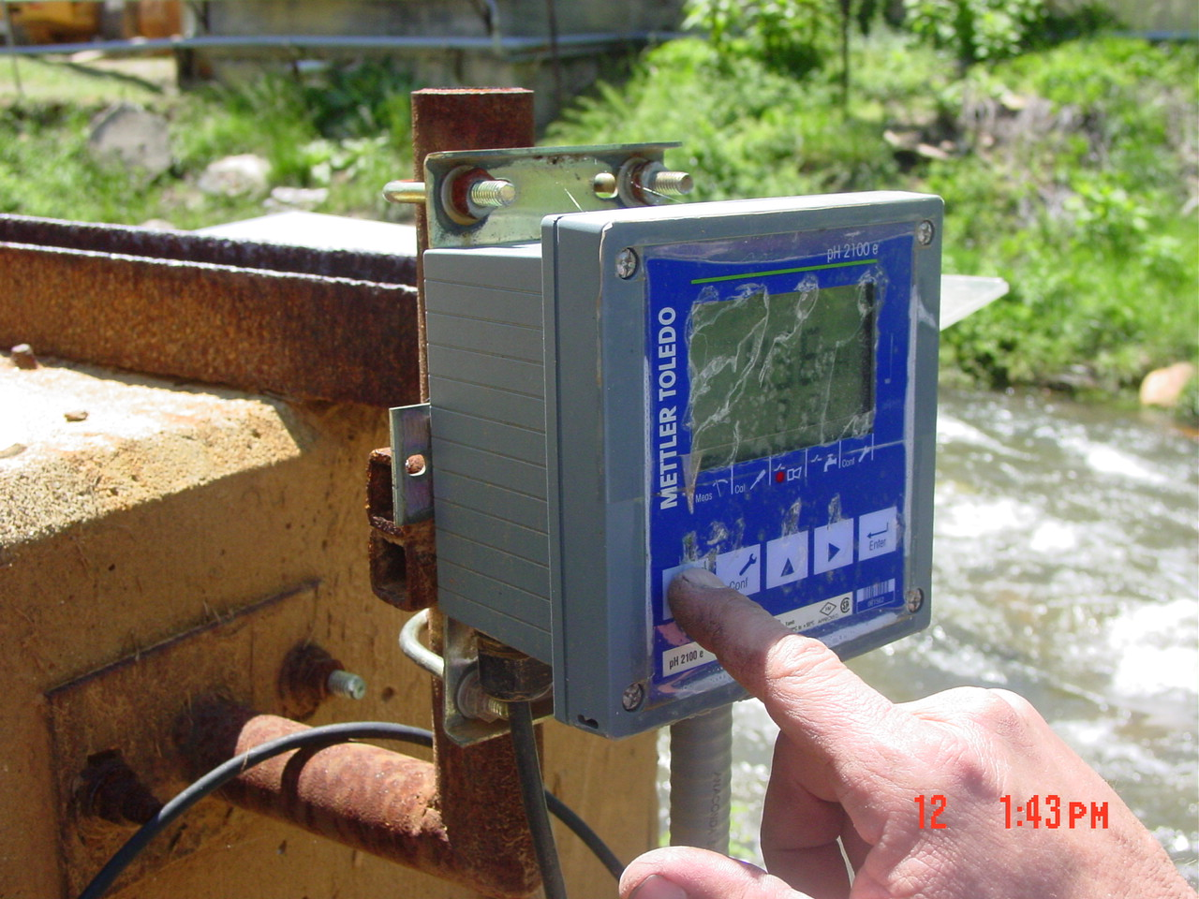

- “0000”should appear in the screen. The first 0 is blinking
- Press the up arrow to enter 1, then press horizontal arrow, the next 0 blinks, press the up arrow again and the readout should now show “1100”, now press enter.
- Cal-1 appears on the screen. Since the probe is in pH 4 buffer already just press enter.
- The meter should read the buffer for pH and mv after completing the process the meter will show Cal-2

- Remove the probe from the pH 4 buffer solution, rinse with clean DI water, dry with a tissue, then place in pH 7 buffer.

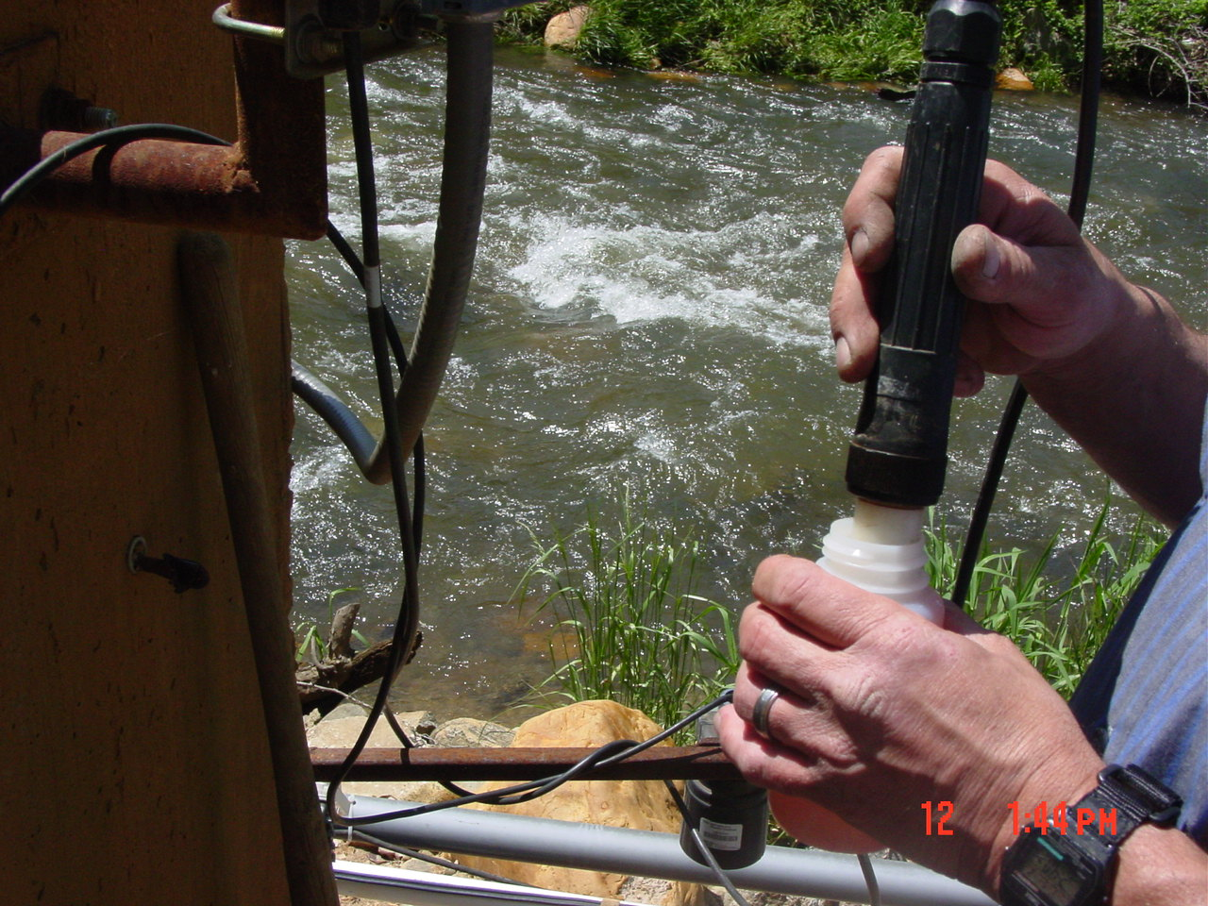

- Press enter then reads the pH and mv. After completing the test, the slope will appear on the screen. 90% and above is acceptable. 85 to 89% must discuss with Technical. Below 85% troubleshoot the system and replace the probe.

- After successfully calibrating press enter two times.

- Observe the reading in the buffer solution.

- Remove probe from buffer solution and rinse with DI water.

- Insert the probe back in the holder and check pH reading against the pH paper.

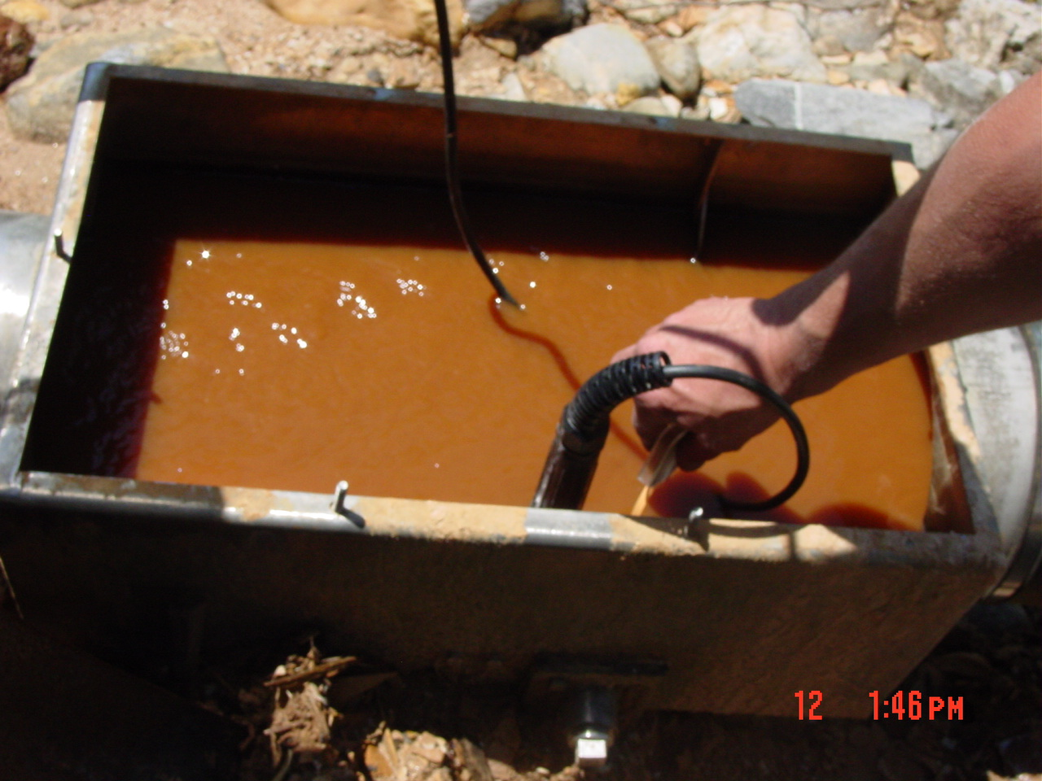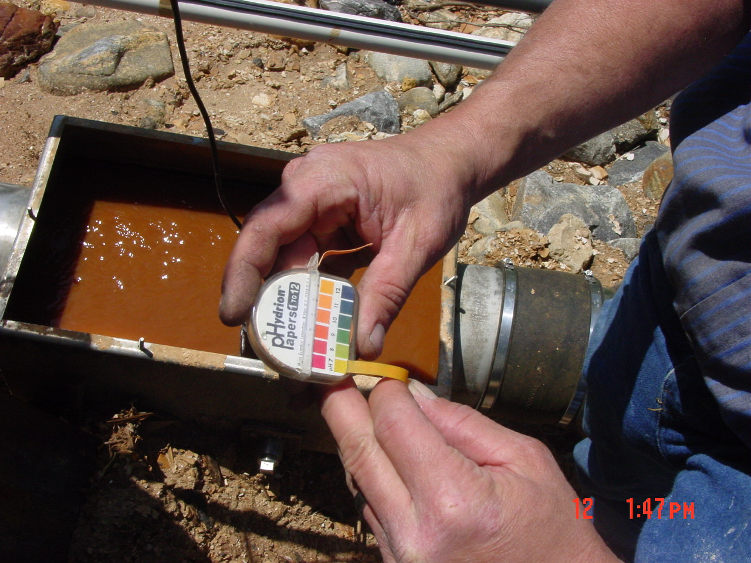

Conduct this calibration procedure at least monthly, or more frequently if needed.

- Reference Documents

N/A

- Amendment Record

Document review- updated format using new template and numbering system.

